Practical-5

Name:-Vishwajit kate

Reg. No:-2020BIT011

# Write a C/C++ Code to implement (With Practical example Implementation)

# 1) Merge Sort

# 2) Binary Search

# 3) Quick Sort

# 4) Strassen's Matrix multiplication

# 1) Merge Sort

# Code:-

// Reg No:2020BIT011

#include <stdio.h>

#include <stdlib.h>

void merge(int arr[], int l,

int m, int r)

{ int i, j, k;

int n1 = m - l + 1;

int n2 = r - m;

int L[n1], R[n2];

for (i = 0; i < n1; i++)

L[i] = arr[l + i];

for (j = 0; j < n2; j++)

R[j] = arr[m + 1 + j];

i = 0;

j = 0;

k = l;

while (i < n1 && j < n2)

{ if (L[i] <= R[j])

{arr[k] = L[i];

i++;}

else

{arr[k] = R[j];

j++;

}

k++;}

while (i < n1) {

arr[k] = L[i];

i++;

k++;}

while (j < n2)

{arr[k] = R[j];

j++;

k++;

}

}

void mergeSort(int arr[],

int l, int r)

{ if (l < r)

{ int m = l + (r - l) / 2;

mergeSort(arr, l, m);

mergeSort(arr, m + 1, r);

merge(arr, l, m, r);

}

}

void printArray(int A[], int size)

{ int i;

for (i = 0; i < size; i++)

printf("%d ", A[i]);

printf("\n");

}

int main()

{

int arr[] = {12, 11, 13, 5, 6, 7};

int arr_size = sizeof(arr) / sizeof(arr[0]);

printf("The Given array is: \n");

printArray(arr, arr_size);

mergeSort(arr, 0, arr_size - 1);

printf("\nThe Sorted array is: \n");

printArray(arr, arr_size);

return 0;

}

**Output:**

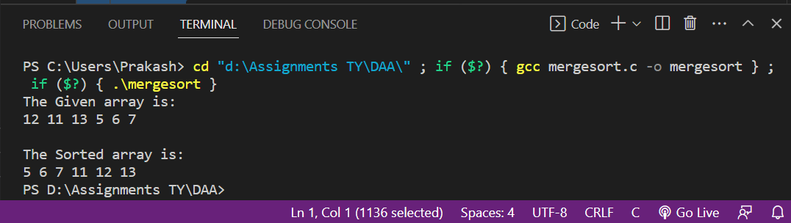

# 2) Binary Search

# Code:-

# // Reg No:2020BIT011

# #include <stdio.h>

# int binarySearch(int arr[], int l, int r, int x)

# { if (r >= l) {

# int mid = l + (r - l) / 2;

# if (arr[mid] == x)

# return mid;

# if (arr[mid] > x)

# return binarySearch(arr, l, mid - 1, x);

# return binarySearch(arr, mid + 1, r, x);

# }

# return -1;

# }

# int main(void)

# { int arr[] = { 2, 3, 4, 10, 40 };

# int n = sizeof(arr) / sizeof(arr[0]);

# int x = 10;

# int result = binarySearch(arr, 0, n - 1, x);

# (result == -1)

# ? printf("Elements not in array")

# : printf("Elements present at index %d", result);

# return 0;

# }

**Output:**

# 3) Quick Sort

# Code:-

// Reg No:2020BIT011

#include <bits/stdc++.h>

using namespace std;

void swap(int* a, int* b)

{

int t = *a;

*a = *b;

*b = t;

}

int partition(int arr[], int low, int high)

{ int pivot = arr[high]; // pivot

int i

= (low

- 1);

for (int j = low; j <= high - 1; j++) {

if (arr[j] < pivot) {

i++;

swap(&arr[i], &arr[j]);

}

}

swap(&arr[i + 1], &arr[high]);

return (i + 1);

}

void quickSort(int arr[], int low, int high)

{ if (low < high) {

int pi = partition(arr, low, high);

quickSort(arr, low, pi - 1);

quickSort(arr, pi + 1, high);

}

}

void printArray(int arr[], int size)

{

int i;

for (i = 0; i < size; i++)

cout << arr[i] << " ";

cout << endl;

}

int main()

{ int arr[] = { 10, 7, 8, 9, 1, 5 };

int n = sizeof(arr) / sizeof(arr[0]);

quickSort(arr, 0, n - 1);

cout << "Sorted array: \n";

printArray(arr, n);

return 0;

}

**Output:-**

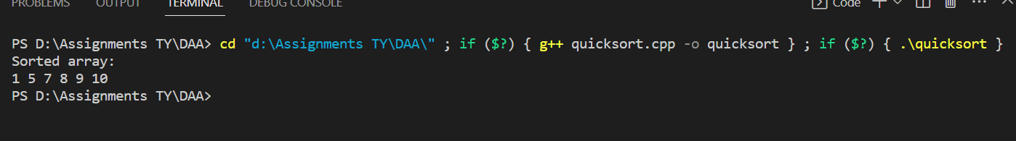

# 4) Strassen's Matrix multiplication

# Code:-

// Reg No:2020BIT011

#include <bits/stdc++.h>

using namespace std;

typedef long long lld;

inline lld** MatrixMultiply(lld** a, lld** b, int n,

int l, int m)

{ lld** c = new lld*[n];

for (int i = 0; i < n; i++)

c[i] = new lld[m];

for (int i = 0; i < n; i++) {

for (int j = 0; j < m; j++) {

c[i][j] = 0;

for (int k = 0; k < l; k++) {

c[i][j] += a[i][k] * b[k][j];

}

}

}

return c;

}

inline lld** Strassen(lld** a, lld** b, int n,

int l, int m)

{ if (n == 1 || l == 1 || m == 1)

return MatrixMultiply(a, b, n, l, m);

lld** c = new lld*[n];

for (int i = 0; i < n; i++)

c[i] = new lld[m];

int adjN = (n >> 1) + (n & 1);

int adjL = (l >> 1) + (l & 1);

int adjM = (m >> 1) + (m & 1);

lld**** As = new lld***[2];

for (int x = 0; x < 2; x++) {

As[x] = new lld**[2];

for (int y = 0; y < 2; y++) {

As[x][y] = new lld*[adjN];

for (int i = 0; i < adjN; i++) {

As[x][y][i] = new lld[adjL];

for (int j = 0; j < adjL; j++) {

int I = i + (x & 1) * adjN;

int J = j + (y & 1) * adjL;

As[x][y][i][j] = (I < n && J < l) ? a[I][J] : 0;

}

}

}

}

lld**** Bs = new lld***[2];

for (int x = 0; x < 2; x++) {

Bs[x] = new lld**[2];

for (int y = 0; y < 2; y++) {

Bs[x][y] = new lld*[adjN];

for (int i = 0; i < adjL; i++) {

Bs[x][y][i] = new lld[adjM];

for (int j = 0; j < adjM; j++) {

int I = i + (x & 1) * adjL;

int J = j + (y & 1) * adjM;

Bs[x][y][i][j] = (I < l && J < m) ? b[I][J] : 0;

}

}

}

}

lld*** s = new lld**[10];

for (int i = 0; i < 10; i++) {

switch (i) {

case 0:

s[i] = new lld*[adjL];

for (int j = 0; j < adjL; j++) {

s[i][j] = new lld[adjM];

for (int k = 0; k < adjM; k++) {

s[i][j][k] = Bs[0][1][j][k] - Bs[1][1][j][k];

}

}

break;

case 1:

s[i] = new lld*[adjN];

for (int j = 0; j < adjN; j++) {

s[i][j] = new lld[adjL];

for (int k = 0; k < adjL; k++) {

s[i][j][k] = As[0][0][j][k] + As[0][1][j][k];

}

}

break;

case 2:

s[i] = new lld*[adjN];

for (int j = 0; j < adjN; j++) {

s[i][j] = new lld[adjL];

for (int k = 0; k < adjL; k++) {

s[i][j][k] = As[1][0][j][k] + As[1][1][j][k];

}

}

break;

case 3:

s[i] = new lld*[adjL];

for (int j = 0; j < adjL; j++) {

s[i][j] = new lld[adjM];

for (int k = 0; k < adjM; k++) {

s[i][j][k] = Bs[1][0][j][k] - Bs[0][0][j][k];

}

}

break;

case 4:

s[i] = new lld*[adjN];

for (int j = 0; j < adjN; j++) {

s[i][j] = new lld[adjL];

for (int k = 0; k < adjL; k++) {

s[i][j][k] = As[0][0][j][k] + As[1][1][j][k];

}

}

break;

case 5:

s[i] = new lld*[adjL];

for (int j = 0; j < adjL; j++) {

s[i][j] = new lld[adjM];

for (int k = 0; k < adjM; k++) {

s[i][j][k] = Bs[0][0][j][k] + Bs[1][1][j][k];

}

}

break;

case 6:

s[i] = new lld*[adjN];

for (int j = 0; j < adjN; j++) {

s[i][j] = new lld[adjL];

for (int k = 0; k < adjL; k++) {

s[i][j][k] = As[0][1][j][k] - As[1][1][j][k];

}

}

break;

case 7:

s[i] = new lld*[adjL];

for (int j = 0; j < adjL; j++) {

s[i][j] = new lld[adjM];

for (int k = 0; k < adjM; k++) {

s[i][j][k] = Bs[1][0][j][k] + Bs[1][1][j][k];

}

}

break;

case 8:

s[i] = new lld*[adjN];

for (int j = 0; j < adjN; j++) {

s[i][j] = new lld[adjL];

for (int k = 0; k < adjL; k++) {

s[i][j][k] = As[0][0][j][k] - As[1][0][j][k];

}

}

break;

case 9:

s[i] = new lld*[adjL];

for (int j = 0; j < adjL; j++) {

s[i][j] = new lld[adjM];

for (int k = 0; k < adjM; k++) {

s[i][j][k] = Bs[0][0][j][k] + Bs[0][1][j][k];

}

}

break;

}

}

lld*** p = new lld**[7];

p[0] = Strassen(As[0][0], s[0], adjN, adjL, adjM);

p[1] = Strassen(s[1], Bs[1][1], adjN, adjL, adjM);

p[2] = Strassen(s[2], Bs[0][0], adjN, adjL, adjM);

p[3] = Strassen(As[1][1], s[3], adjN, adjL, adjM);

p[4] = Strassen(s[4], s[5], adjN, adjL, adjM);

p[5] = Strassen(s[6], s[7], adjN, adjL, adjM);

p[6] = Strassen(s[8], s[9], adjN, adjL, adjM);

for (int i = 0; i < adjN; i++) {

for (int j = 0; j < adjM; j++) {

c[i][j] = p[4][i][j] + p[3][i][j] - p[1][i][j] + p[5][i][j];

if (j + adjM < m)

c[i][j + adjM] = p[0][i][j] + p[1][i][j];

if (i + adjN < n)

c[i + adjN][j] = p[2][i][j] + p[3][i][j];

if (i + adjN < n && j + adjM < m)

c[i + adjN][j + adjM] = p[4][i][j] + p[0][i][j] - p[2][i][j] - p[6][i][j];

}

}

for (int x = 0; x < 2; x++) {

for (int y = 0; y < 2; y++) {

for (int i = 0; i < adjN; i++) {

delete[] As[x][y][i];

}

delete[] As[x][y];

}

delete[] As[x];

}

delete[] As;

for (int x = 0; x < 2; x++) {

for (int y = 0; y < 2; y++) {

for (int i = 0; i < adjL; i++) {

delete[] Bs[x][y][i];

}

delete[] Bs[x][y];

}

delete[] Bs[x];

}

delete[] Bs;

for (int i = 0; i < 10; i++) {

switch (i) {

case 0:

case 3:

case 5:

case 7:

case 9:

for (int j = 0; j < adjL; j++) {

delete[] s[i][j];

}

break;

case 1:

case 2:

case 4:

case 6:

case 8:

for (int j = 0; j < adjN; j++) {

delete[] s[i][j];

}

break;

}

delete[] s[i];

}

delete[] s;

for (int i = 0; i < 7; i++) {

for (int j = 0; j < (n >> 1); j++) {

delete[] p[i][j];

}

delete[] p[i];

}

delete[] p;

return c;

}

int main(){

lld** matA;

matA = new lld*[2];

for (int i = 0; i < 2; i++)

matA[i] = new lld[3];

matA[0][0] = 1;

matA[0][1] = 2;

matA[0][2] = 3;

matA[1][0] = 4;

matA[1][1] = 5;

matA[1][2] = 6;

lld** matB;

matB = new lld*[3];

for (int i = 0; i < 3; i++)

matB[i] = new lld[2];

matB[0][0] = 7;

matB[0][1] = 8;

matB[1][0] = 9;

matB[1][1] = 10;

matB[2][0] = 11;

matB[2][1] = 12;

lld** matC = Strassen(matA, matB, 2, 3, 2);

for (int i = 0; i < 2; i++) {

for (int j = 0; j < 2; j++) {

printf("%lld ", matC[i][j]);

}

printf("\n");

}

return 0;

**Output:-**

